**Total Chl a**

**ln(Total Chl a + 1)**

one less significant p value

**Cyanobacteria**

**ln(cyanobacteria + 1)**

**has one less significant**

**Green Algae**

**Ln(Green Algae +1)**

**more significant p values**

**Cryptophytes**

**Ln(Cryptophytes + 1)**

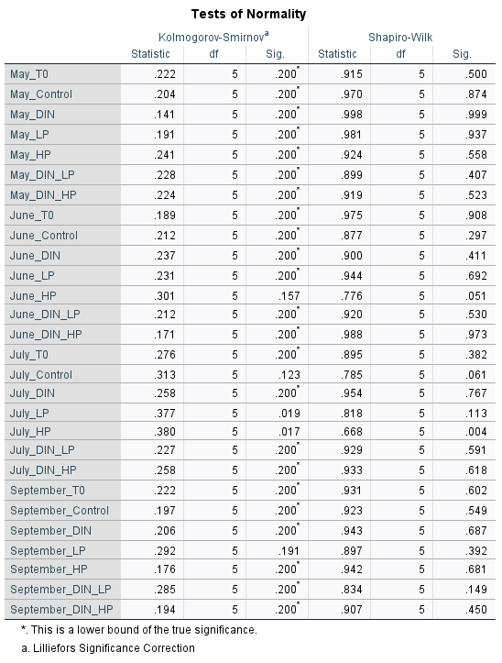**no different**

**Diatoms**

**Ln(Diatoms + 1)**

**same amount but dif?**

**Dinoflagellates**

**Ln(dinoflagellates + 1)**

**one less**

**Haptophytes**

**Ln(hapto + 1)**

**maybe one less**

